Lesson 02 Demo 05

Creating Management Groups

Objective: To create management groups using Azure portal

Tools required: Azure Active Directory user

Prerequisites: Azure Active Directory tenant

Steps to be followed:
- Create a management group

Step 1: Create a Management Group

- Sign in to the Azure portal

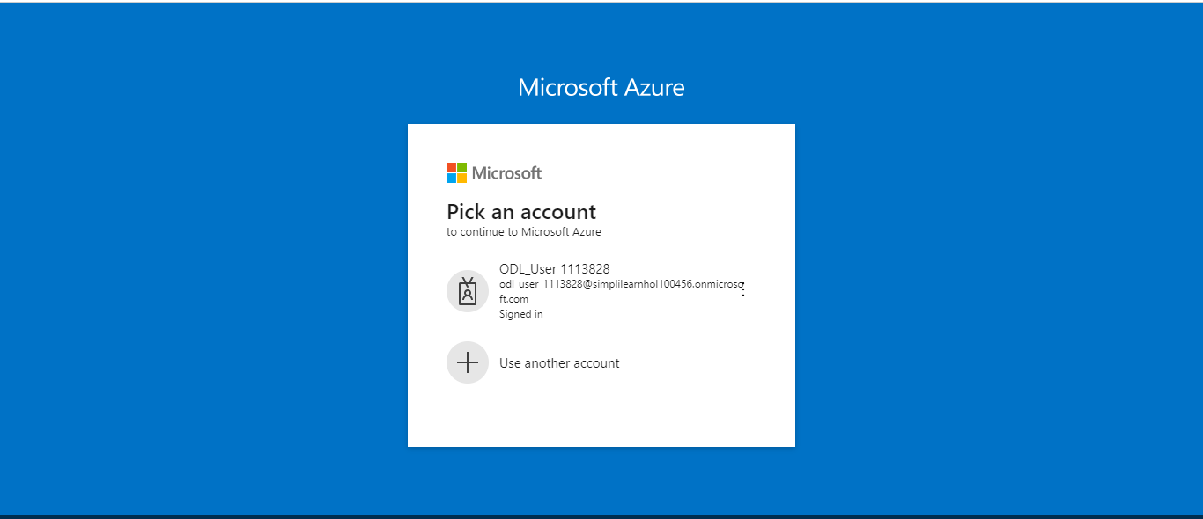

- Click on More services

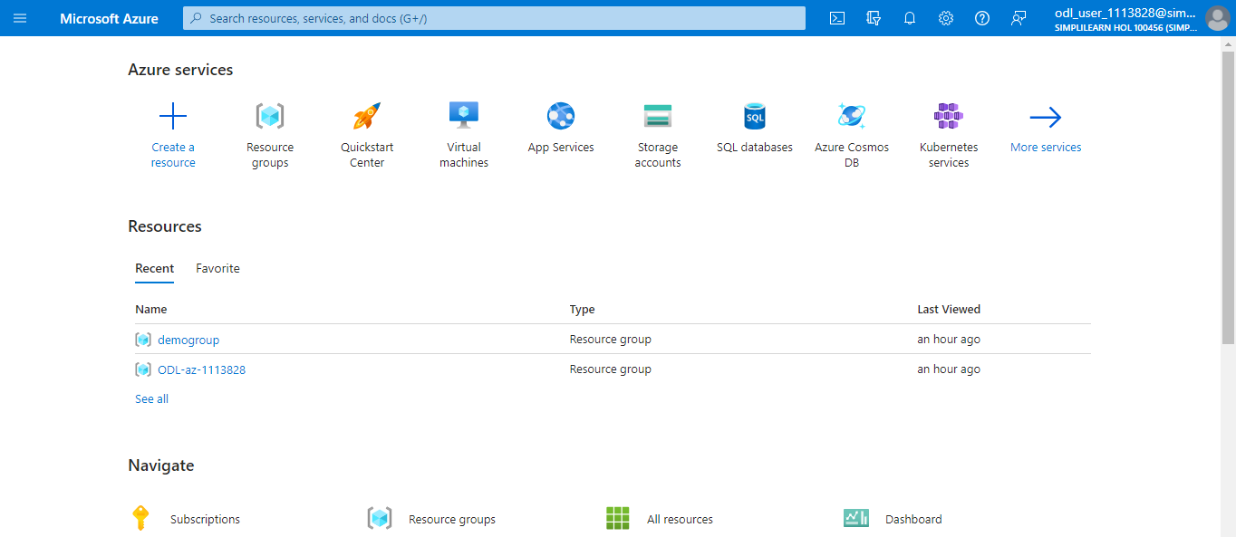

1.3 From the portal menu, select All services

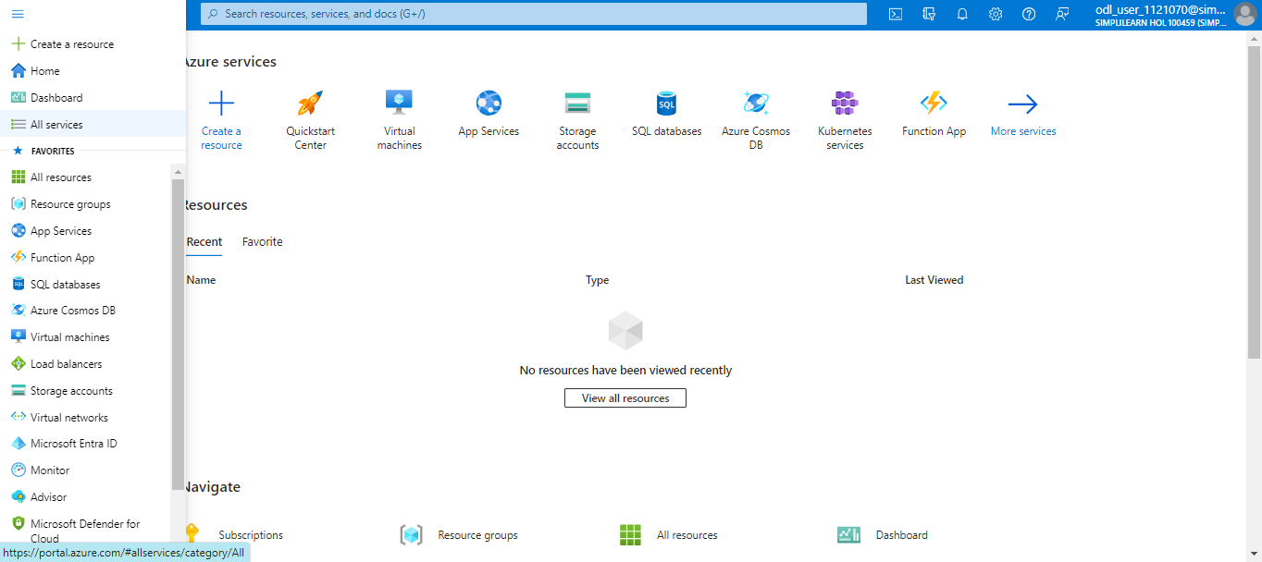

  - From All services, select Management and governance

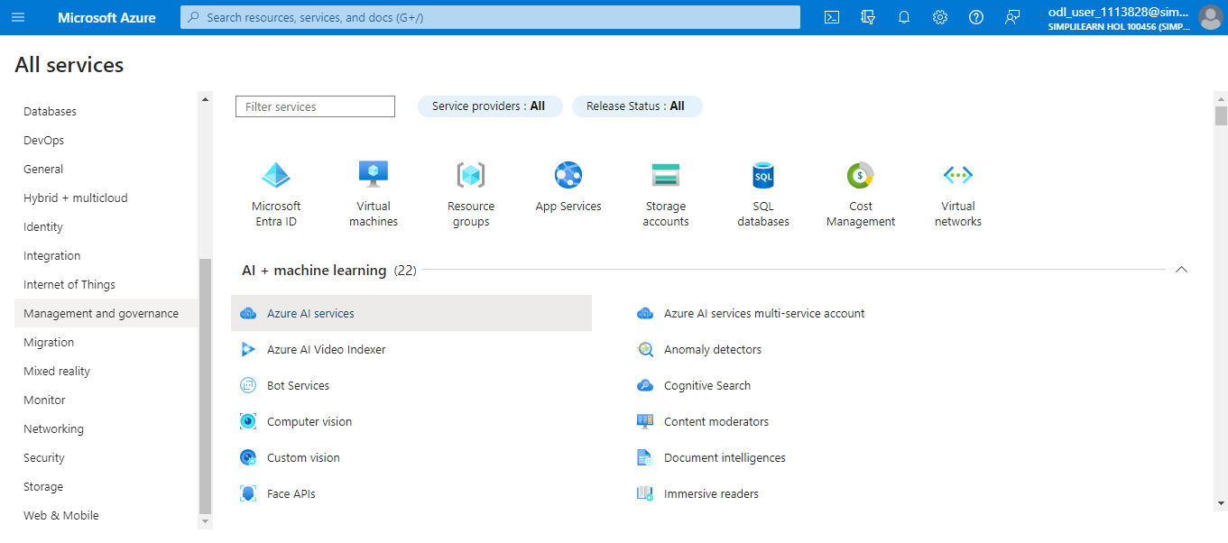

  - Select Management groups

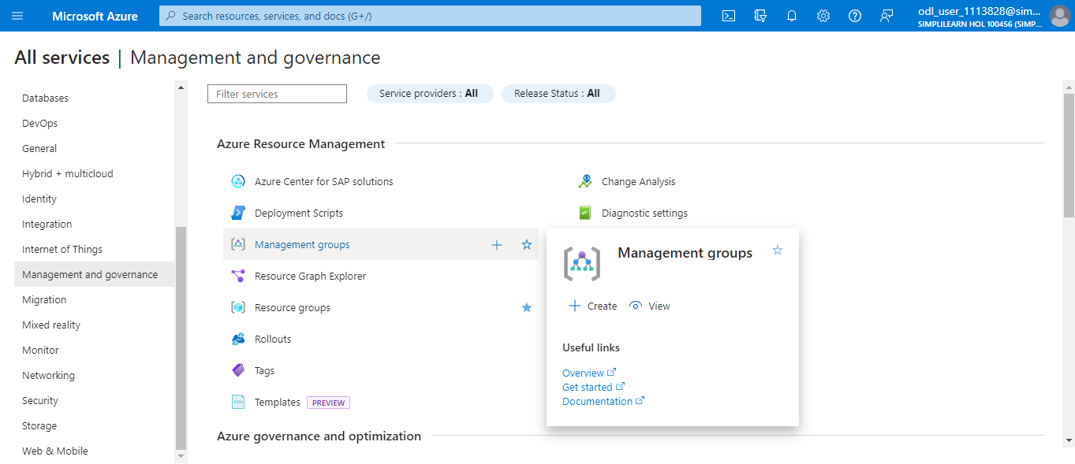

It will list all the management groups created with respect to the tenant including Tenant Root Group as shown below:

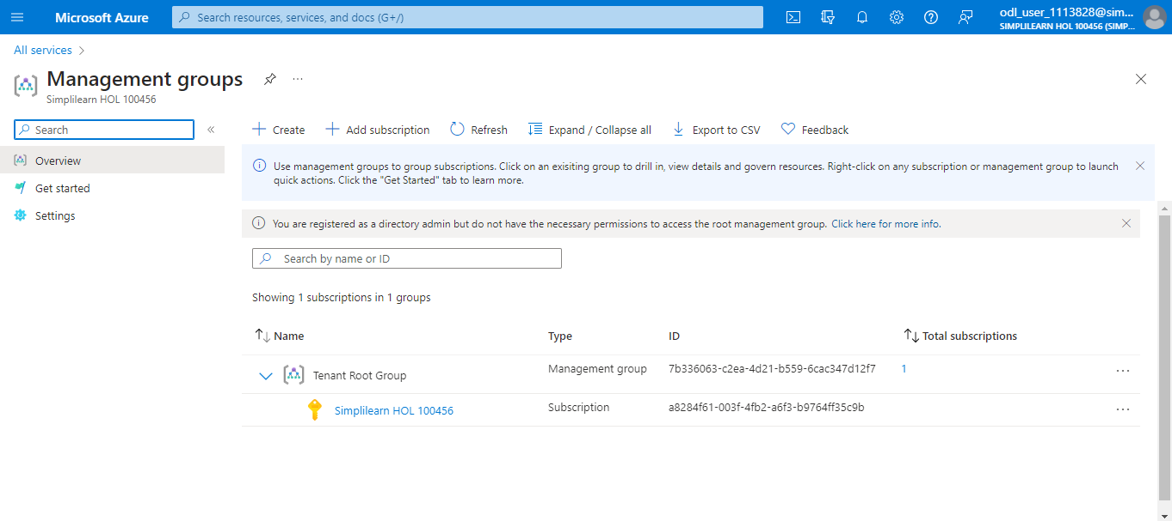
1.6 Select + Create
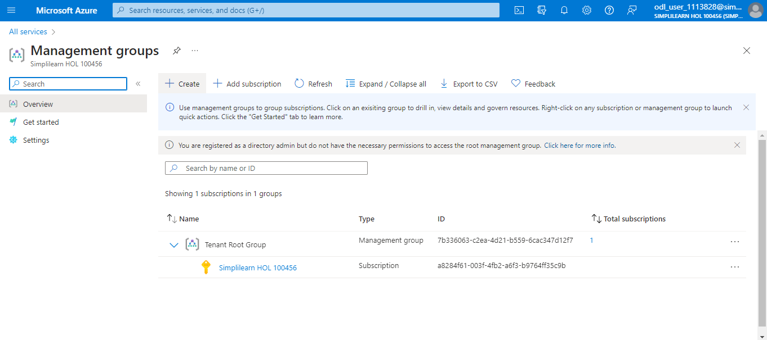

1.7 Fill in the Management group ID and the Management group display name fields
- The Management group ID is the directory unique identifier that is used to submit commands on this management group. This identifier isn't editable after creation, as it's used throughout the Azure system to identify group. The root management group is automatically created with an ID that is the Azure Active Directory ID. For all other management groups, assign a unique ID.

- The display name field is the name that is displayed within the Azure portal. A separate display name is an optional field when creating the management group and can be changed at any time.

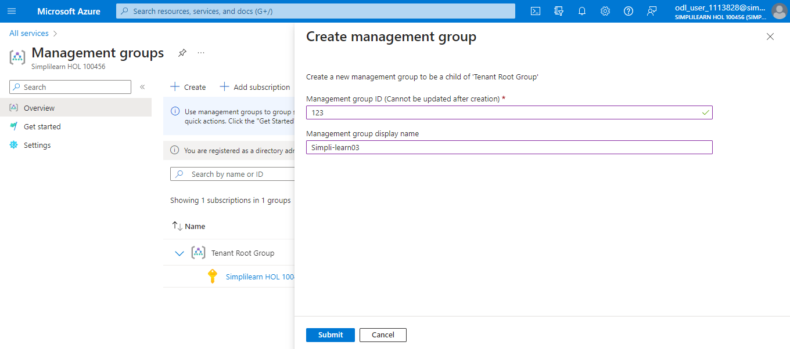

1.8 Select Submit to create a new management group with the desired name
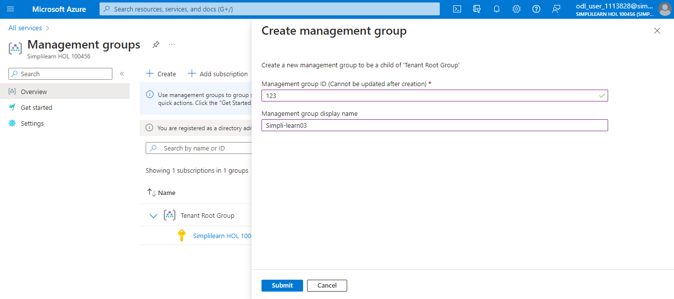

A new management group with the desired name will be created as shown:

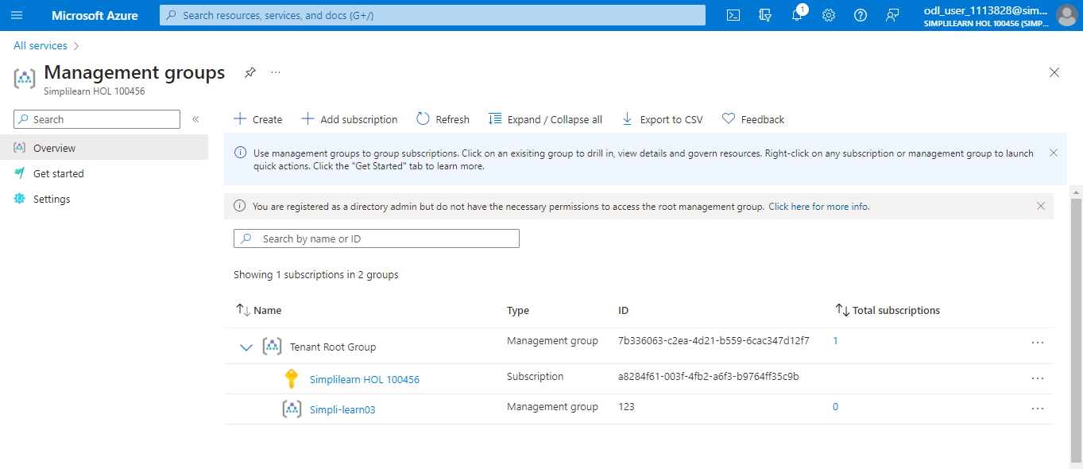

You have now successfully created management groups using the Azure portal.

